3-D FINAL- SLAB ROLLED VASE-50 pts
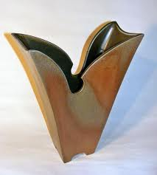
Students are to design and create a slab rolled vase. Using the techniques learned for the semester, apply your knowledge of the slab roller, surface decoration and construction to create an attractive vase.
Please include the following techniques in your project:
- Good Craftsmanship
- Surface Decoration
- Recreation of Design Plan
- Proper Glazing Techniques
- Use of Reconstituted Clay

***Students will be using the critique/self assessment method for grading********

3-D FINAL- SLAB ROLLED VASE-50 pts
Students are to design and create a slab rolled vase. Using the techniques learned for the semester, apply your knowledge of the slab roller, surface decoration and construction to create an attractive vase.
Please include the following techniques in your project:
- Good Craftsmanship
- Surface Decoration
- Recreation of Design Plan
- Proper Glazing Techniques
- Use of Reconstituted Clay

***Students will be using the critique/self assessment method for grading********

