Barbie in a Box

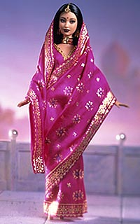
Students investigate stereotypes of women and use the information to brainstorm ideas to recreate a Barbie in a box scene.

Questions to ask?
- What are the different types of stereotypes that Barbie has portrayed in the past?
- Who decides what Barbie wears and is portrayed?
- How does advertising play a role in stereotypes?
- What effects does stereotypes have on thinking?

Option 1
Student

