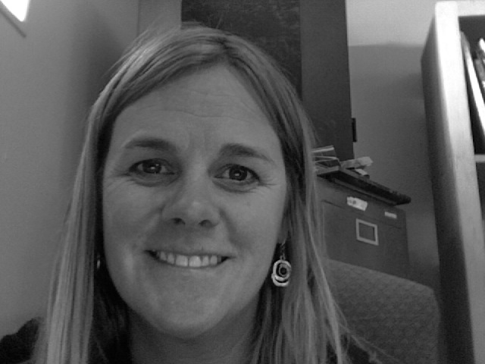

“If you hear a voice within you say 'you cannot paint,' then by all means paint, and that voice will be silenced.” –Vincent Van Gogh

Hello! My name is Sarah Buss and this is my fifth year here at FALA. I am the teacher for Art Basics, Intro to Art, Contemporary Craft and 3-D design. I am a graduate of Northern Arizona University with a B.S. in Education and a certificate to teach art K-12.

My curriculum is based on providing students with an intensive engagement in the visual arts by teaching them to look at art, use basic studio techniques, and understand works of art within their cultural and historical contexts.

As well as being a full time art teacher I also serve on the FALA Council, a shared decision making body, that works toward professional, educational and technological goals of the school.

.

