Chuck Close Value Grid Drawing-Final-60pts.
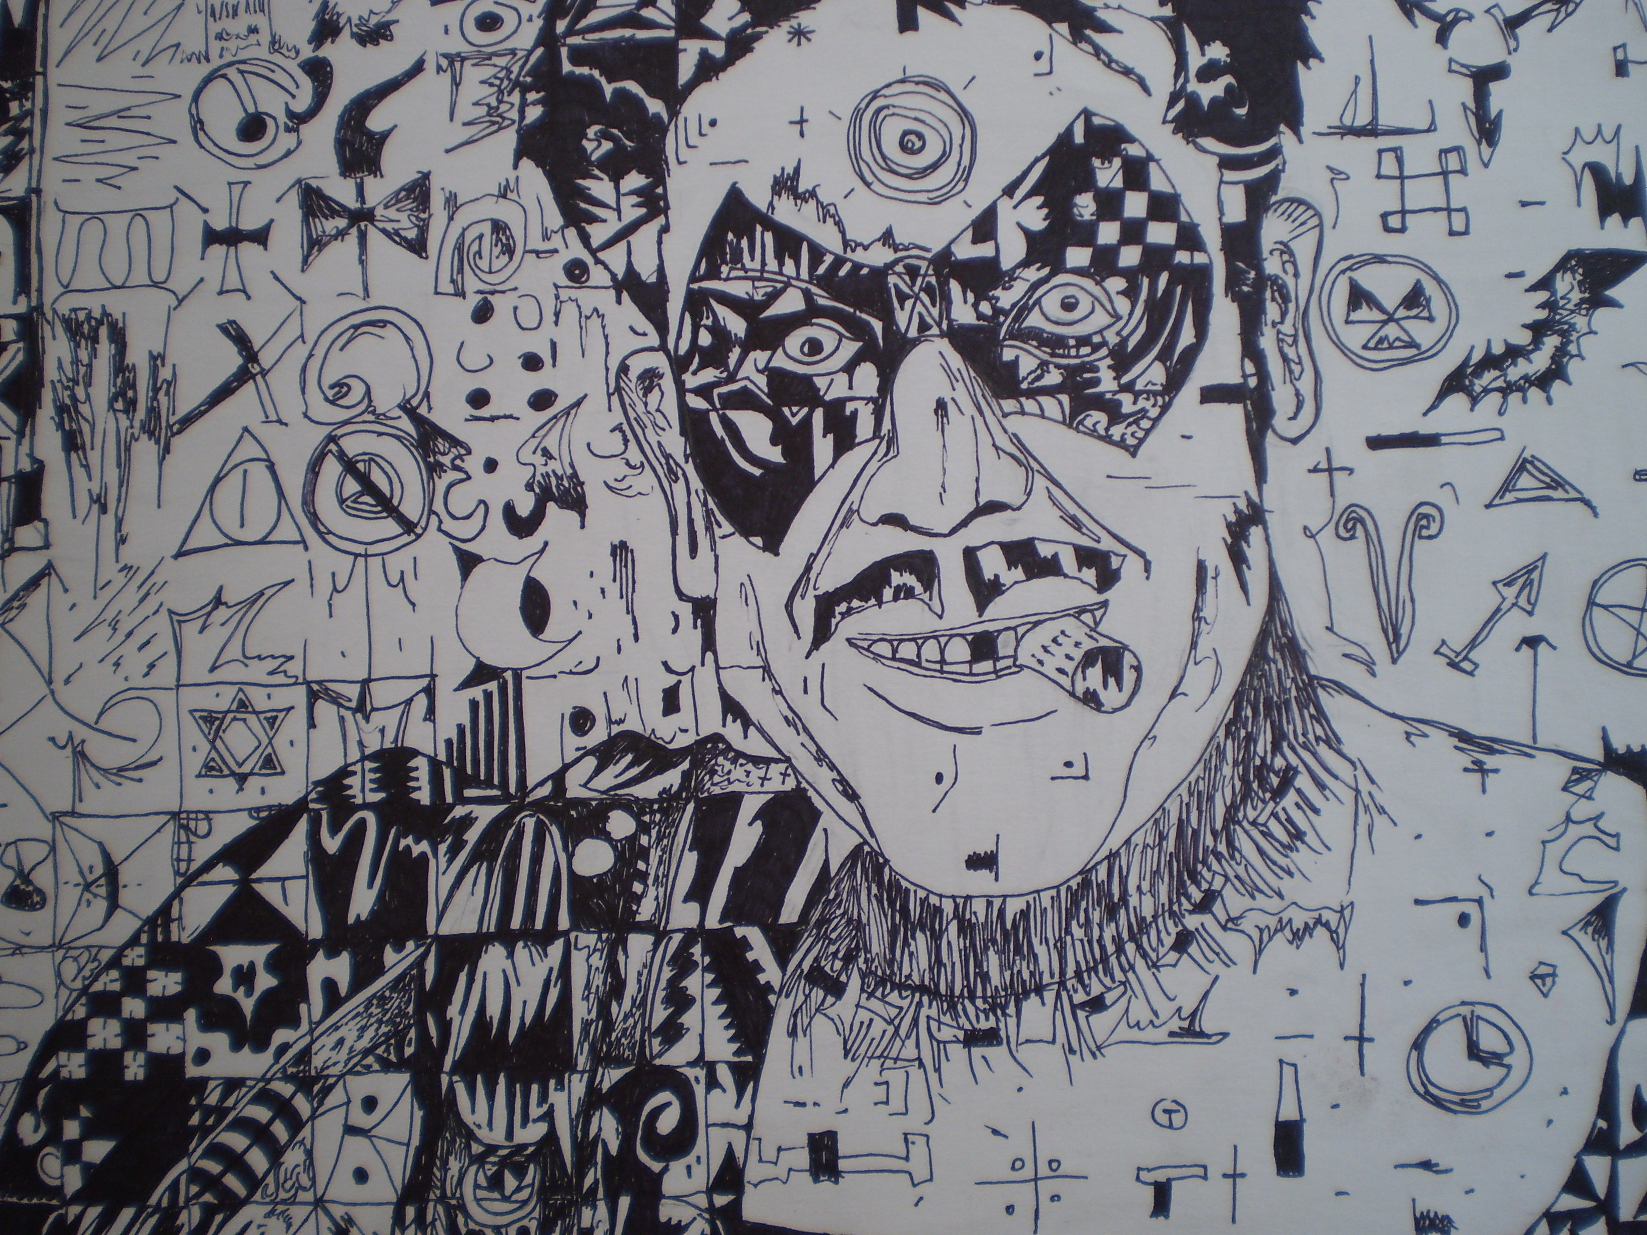

Students are to use their knowledge of value to create a grid drawing that is in the style of Chuck Close.

Rules for Photo:
- MUST be a black and white photo of a REAL PERSON (no cartoons)
- Photo should have a wide range of values, it is helpful to have many high contrasting areas in the photo
- Photo must be a head shot

Directions:
- Chose a photo and paste it into a word document, size it to be 6”x8”
- Using a ultra fine tip sharpie put a 1/2” grid on the photo
- Using very light pencil marks put a 1 inch grid on a 12x18 piece of paper
- Make an outline in pencil of the person in the photo
- Use ultra fine tip sharpie to fill in different types of value to your piece (If a student can complete the whole picture without EVER repeating a pattern 10 points extra credit will be given
- TRUST THE GRID!! Your picture will turn out perfect if you follow the grid

Rubric:
Student used different patterns that use expressive line | 1-2-3-4-5-6-7-8-9-10
Student demonstrates proper use of positive and negative space | 1-2-3-4-5-6-7-8-9-10

Student demonstrated knowledge of value completing a grid drawing | 1-2-3-4-5-6-7-8-9-10
Student used different value patterns to complete drawing-must not repeat a pattern more than 5 times | 1-2-3-4-5-6-7-8-9-10
Student demonstrated effort and perseverance until the project was complete. NO WASTING TIME!!! | 1-2-3-4-5-6-7-8-9-10
Student demonstrated good craftsmanship. | 1-2-3-4-5-6-7-8-9-10

Comments:

