Elements of Art-Line
Line (10pts.) | Used to define space, uses contours and outlines to suggest mass or volume.  Types and Examples:  - Descriptive Lines-Lines that help us understand what we are seeing (Draw a box in your book and draw an original example)  - 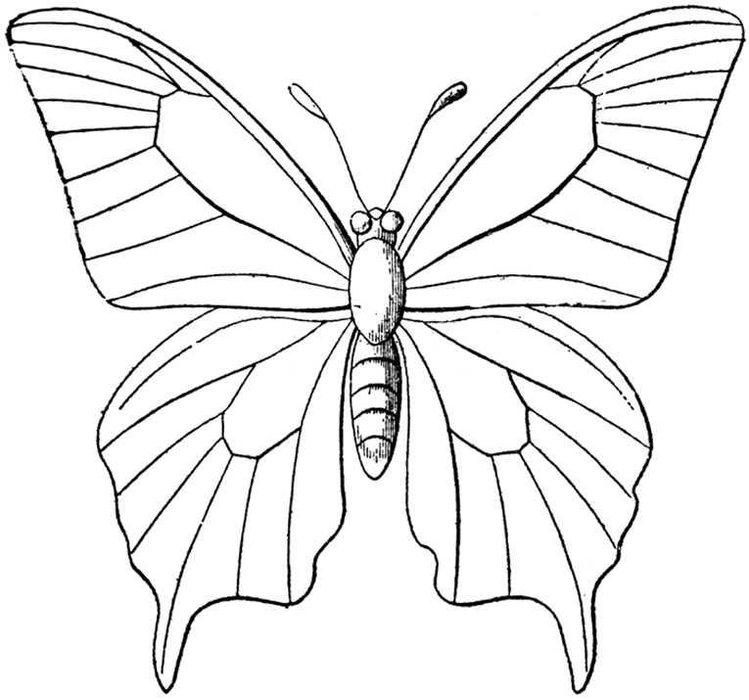  - Contour Lines-Define outer edges, vary in thickness,give depth to an object (Draw a box in your book and draw an object in the room)  - 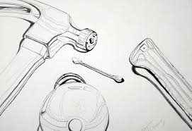  - Hatching and Cross hatching-Using close parallel lines to suggest light and shadow (Draw a box in your book and draw an original example)  - 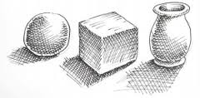  - Expressive lines-Lines that are produced to express an idea, mood or quality. (draw a box)  - Implied Lines-Suggested lines in a photo or picture
Shape | A two dimensional area with a recognizable boundary.  Types and Examples:  - Organic (draw a box)  - Geometric (draw a box)
Color
Form
Value
Texture
Space

