Elements of Art-Form and Value

- Value-The lightness or darkness of tones or colors. White is the lightest value; black is the darkest. The value halfway between these extremes is called middle gray. (Create the following value scales in your notes)
- 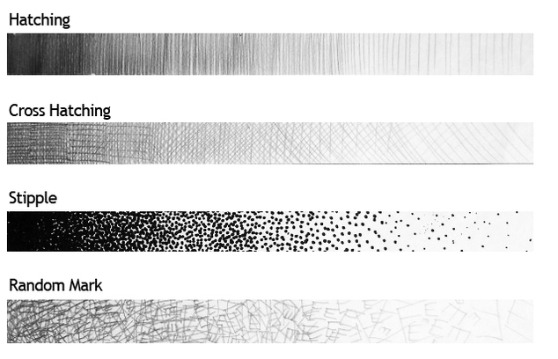

- Form-An element of art that is three-dimensional and encloses volume; includes height, width AND depth (as in a cube, a sphere, a pyramid, or a cylinder). Form may also be free flowing. Draw an object from observation
