Expressive Contour Line Hands
One of the most important skills to have as an artist is to be able to draw from observation. This skill takes practice, but once it is mastered students will find that it opens up many doors to being creative with many types of mediums. This project is designed to explore drawing contour line drawing of the hand and the background is to further your development with expressive lines.

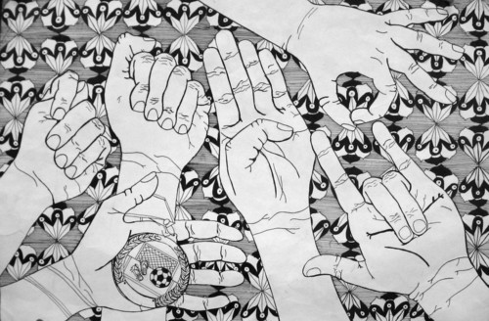
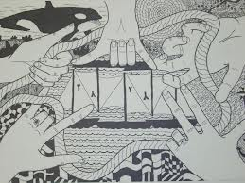

Rubric:
Student has at least 5 contour line drawings of their hand. | 1-2-3-4-5
Student filled the ENTIRE background with expressive lines. | 1-2-3-4-5
Student worked on project until it was finished and did not rush or waste time. | 1-2-3-4-5
Students project has good craftsmanship. | 1-2-3-4-5
