Fauvist Self Portrait-Oil Pastels
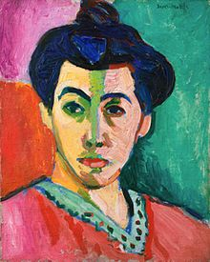
Students are to create a composition in the style of the Fauvists using oil pastels.

Rubric:

Student created a picture in a Fauvist style. 1-2-3-4-5

Student used layers of pastels to create depth 1-2-3-4-5

Student did not waste time. 1-2-3-4-5

Student has good craftsmanship, all pastels are blended .
1-2-3-4-5

Fauvist Self Portrait-Oil Pastels
Students are to create a composition in the style of the Fauvists using oil pastels.

Rubric:

Student created a picture in a Fauvist style. 1-2-3-4-5

Student used layers of pastels to create depth 1-2-3-4-5

Student did not waste time. 1-2-3-4-5

Student has good craftsmanship, all pastels are blended .
1-2-3-4-5

