Final Art and Design-

Students demonstrate the techniques of expressive line and value by creating a grid project of their choice. Students build off a project completed in Art basics, but chose their own subject matter and bump up to a 18X24 canvas.
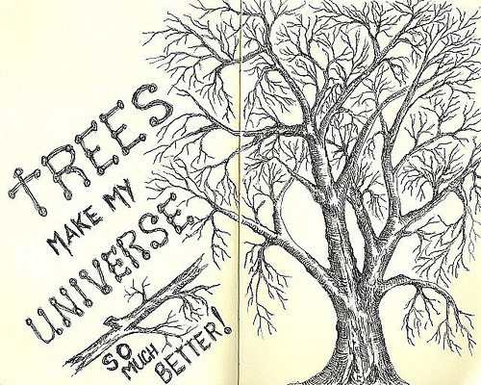
Techniques that are required:
- VALUE
- IMAGE TRANSFER
- EXPRESSIVE LINE
- CRAFTSMANSHIP

*******STUDENTS WILL BE COMPLETING A SELF EVALUATION AND GROUP CRITIQUE********

