Bad Hair Day-A Study of Contour and Descriptive Line
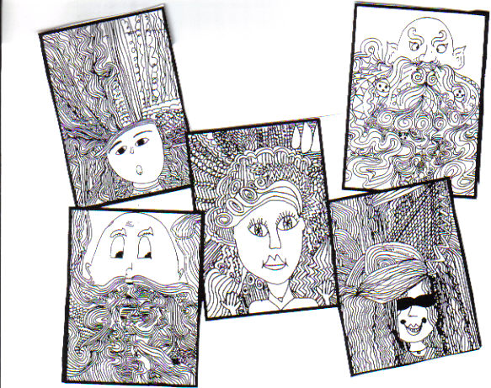

Students use their knowledge of contour and descriptive line to create a “Bad Hair Day” portrait. Using the space below practice using expressive lines.

Rubric:
Student demonstrated proper use of descriptive line by using at least 8-10 DIFFERENT line patterns. | 1-2-3-4-5
Student demonstrated proper use of contour lines by creating a face with features. | 1-2-3-4-5
Student displayed good craftsmanship. | 1-2-3-4-5
Student demonstrated effort and perseverance until the project was complete.

