Mixed Media Mobiles-30 pts.
Students will be exploring different types mixed media techniques to create mobiles.

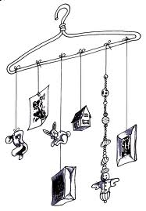
Checklist-20 pts

- 7 Bottle Cap Images
- 3 Image Transfers
- 2 Wire Sculptures
- 2 Felt Ornaments
- 2 Water color images
- 3 wire sculptures

Effort and Craftsmanship-10 pts
- Make sure your project is well constructed and you demonstrate effort until the project is finished (no wasting time).

Comments:

Mixed Media Mobiles-30 pts.
Students will be exploring different types mixed media techniques to create mobiles.

Checklist-20 pts

- 7 Bottle Cap Images
- 3 Image Transfers
- 2 Wire Sculptures
- 2 Felt Ornaments
- 2 Water color images
- 3 wire sculptures

Effort and Craftsmanship-10 pts
- Make sure your project is well constructed and you demonstrate effort until the project is finished (no wasting time).

Comments:

