Printmaking Workshop-Diptychs
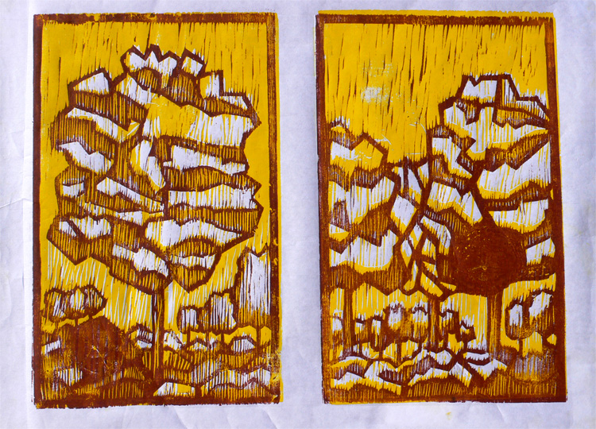
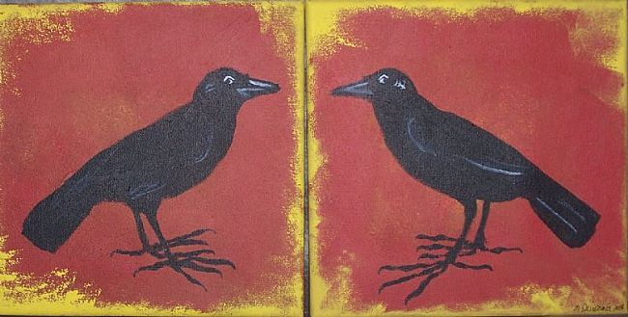

A Diptych can be a continuation of the same picture or two pictures with similar content.

Please research artists that use diptychs in their art. Search ideas: diptych (paintings, artists, printmaking) Find at least 3 pictures that interest you. What specifically do you like about these images?

Image 1

Image 2

Image 3

Look up images of printmaking. Search ideas printmaking (black and white, texture, birds, trees ,etc.) Find at least three images that interest you. What is it about these images that interest you.)

Image 1

Image 2

Image 3

Go to youtube and watch a couple videos on printmaking. What techniques does the artist use to create desired effects?

Printmaking artists pay attention to the negative space of a composition. Explain how this is important in printmaking.

Please get design paper and start to design you diptych.

