The Element of Color

Color is the element of art that is produced when light, striking an object, is reflected back to the eye.

Students design their own color wheel..

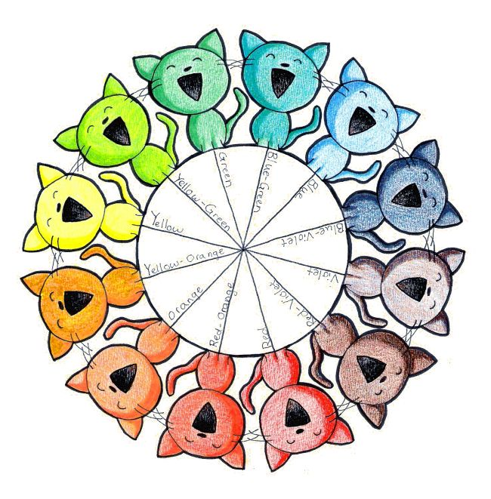
Shades-Adding black to a color
Tints-adding white to a color

